- Which 3 products sold the most units in the most recent full calendar month?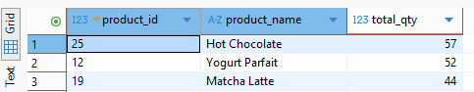

- Identify higher-value customers for loyalty perks or targeted offers.
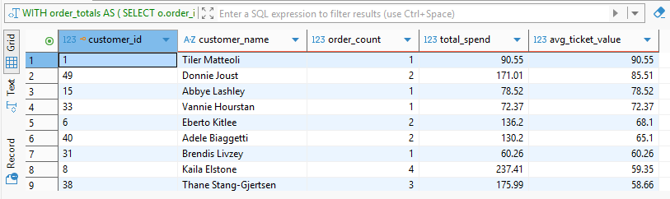

- By category, what are revenue, cost, gross margin, and margin %?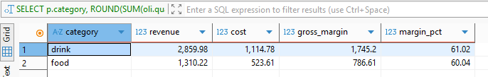

- Which customers have high points but haven’t ordered in the last 60 days?
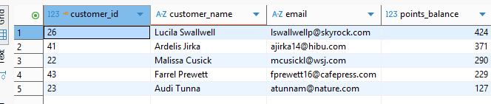

- What % of orders are cash vs card vs mobile?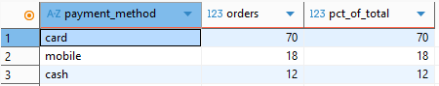

- How many items do customers buy per order, overall and by channel (in-store vs app)?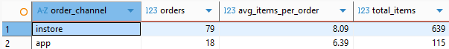

- Which baristas drive the most orders and revenue? What is their avg order value?
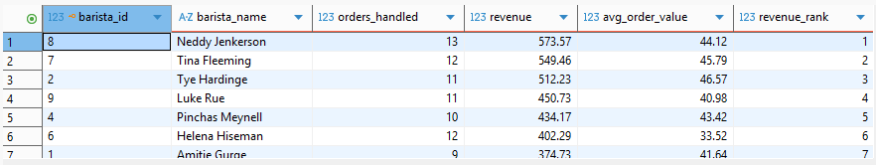

- How do orders with a promotion compare to those without?

